# Introduction

This is a card game with classic solitaire movements. The goal is for the user to place all cards in the four foundation piles at the top of the board. Points are calculated based on the amount of movements the user does. This document will assist in downloading and setting up the game, as well as troubleshooting common errors.

# Game instructions

The game starts with a talon pile, four empty foundation piles and 7 stockpiles with cards placed faced down and one face up. The user can double click cards in the talon pile to flip them right side up or can drag and drop cards on top of one another. Foundation piles can only accept an ace of each suit. Once the ace is placed in their foundation pile , the user can begin stacking ascending cards in the same suit. For the stockpile, the users can place cards in descending ranks in alternating suits. When a place is free on the board, a King can be placed in that position. Points are collected by the number of cards collected in the stockpile and how quickly the user is able to free up their board of cards.

# System requirements

The game is to be run on a computer with Visual Studio Code. If you do not have Visual Studio you can dowload it [here for a free download.](https://visualstudio.microsoft.com/downloads/)

# Download and installation Instructions

1. **Access Github using the below link:**

[Release Solitaire V.2 · Peac777/SolitaireGame (github.com)](https://github.com/Peac777/SolitaireGame/releases/tag/v1.2.3)

1. **In Github select Releases**

1. **Once you have selected releases you can select the newest version of the game.**

Once the Zip is downloaded, access your file explorer in downloads and extract the file in your desired folder.

1. **Open Visual Studio**
2. **Select File> Open Folder and select the unzipped Game folder.**
3. **Run the game in visual studio**

# User Manual

**Game Board:**

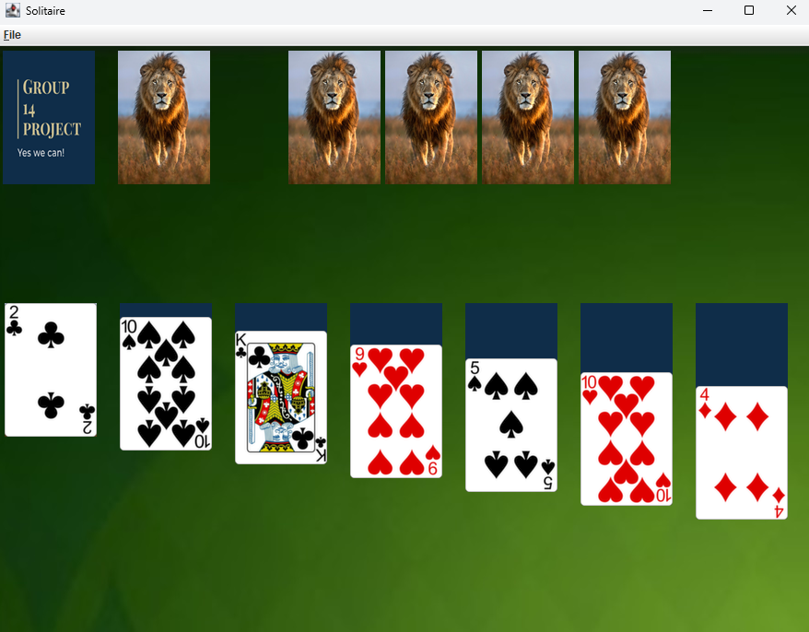

**Controls:**

**Single Mouse Click**: Flip deck cards to wastepile.

**Buttons:** user buttons to create new game, exit game and for game rules.

**Drag and Drop:** Drag and drop cards from wastepile to foundations or tableau piles.

**New game:**

To deal a new game select File > new game on the top left hand side.

**Winning and Scoring**:

**Score:** Each card added to the foundations will give you 10 points

**Win:** You will win when all playing cards are in the foundation piles.

# Troubleshooting

If Java runtime environement is not opening the game, you may need to uninstall java and reinstall.

Restart your computer and try again.

# Q&A

**Q: The game is on my desktop but it isnt playing**

A: Verify that your Visual Studio is up to date.

**Q: Where can I download the game?**

A: Using the link[Releases · Peac777/SolitaireGame (github.com)](https://github.com/Peac777/SolitaireGame/releases) you can view the latest release.

**Q. How do I get notified of newer releases?**

A. By selecting Watch on the repository you will be notified of any new features or new releases. Follow the creator.

